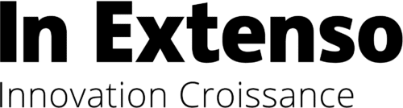


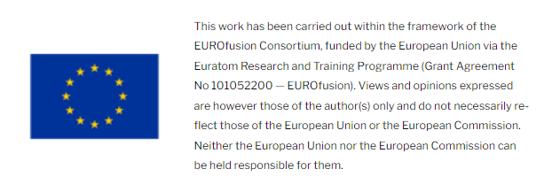
OPEN CALL FOR EUROFUSION-BASED TECHNOLOGY TRANSFER DEMONSTRATORS
Proposal Template
March 2026
In Extenso Innovation Croissance

COVER LETTER
SUBJECT: [insert subject/title of the proposal]
Dear Madam, dear Sir,
In response to the Open Call (the Call) issued by IEIC, we are pleased to submit proposal.
Please find attached hereto the following documents:
- Executive Summary
- Proposal of technology transfer Demonstrator (incl. at least one letter of intent)
- Additional Information (if any)
We claim here below the following statements:
- This proposal is valid for [insert number of months] from the date of submission [with a minimum period of 6 months];
- The applicant [insert name of company] is registered and established in [insert name of country];
- The Application is compliant with the Requirements set out in the Call;
- The Application for a proposed transfer is based on a transfer of EUROfusion related technology or know-how in a non-fusion environment;
- The draft Contract has been read, understood and accepted;
- A statement of compliance with the price of [add budget claimed] stated in the Call;
- The non-fusion application foreseen shall not promote activities, or be related to the military, alcohol, tobacco, religion, politics, intolerance, violence, firearms, pornography, obscenity, gambling or illegal drugs
- IEIC is allowed to include the electronic version of the Public Summary of the work carried out in its demonstrator database with public access.
- We [would like / don’t want] to request extra support up to 25% Full Time Equivalent (3 person months) of fusion scientist/s through the Work Package FUTTA, inline with the EUROfusion co-funding rules and reimbursement rates.
Any queries relevant to the proposal are to be addressed to the attention of:
- [insert name]
- Address:
- Phone: Email:
Contact information of the legal representative who will be in charge of signing the contract:
- [insert name]
- Address:
- Phone: Email:
Signature & Date

EXECUTIVE SUMMARY
The Applicant is asked to produce an executive summary. The executive summary for accepted proposals may be published openly by In Extenso Innovation Croissance and EUROfusion. The executive summary shall cover the following aspects, in maximum one page:
- Descriptive Title : Provide an easily understandable title
- EUROfusion origin/heritage : Indicate the link between the technology or know-how with EUROfusion activities and precise which key technology development have been made so far in fusion applications (including any intellectual property)
- Non-fusion application : Indicate which non-fusion market opportunity has been identified (including any potential customer relationships) and why the technology under development may provide significant advantage for this application
- Work Implementation : Describe the technological step to be made during the implementation of the Transfer Demonstrator project and precise the Resources to be provided by the contractor to support the creation of the Transfer Demonstrator
- Letter of Support: Precise the support of the other party in this proposal

FULL PROPOSAL
The proposal shall cover the following aspects; it shall not be longer than 10 pages, excluding cover letter and annexes.
- Description of the EUROfusion origin/heritage of the technology or know-how :
  - Indicate the link between the technology with EUROfusion activities (EFDA, EUROfusion, EFDA with IPR added under EUROFusion, EURATOM on Copyright) through mentioning a contract, a WP or a project for example
  - Indicate which key technology development have been made so far in fusion applications (including any intellectual property)
  - Precise the Technology Readiness Level reached for fusion applications

- Description of the non-fusion application targeted and competitive advantage created by the fusion technology:
  - Precise Status of technology development for the potential application
  - Precise the Technology Readiness Level for the non-fusion application(s)
  - Explain the non-fusion technology/market opportunity including any potential customer relationships and why the technology under development may provide significant advantage for this application
  - Share report on any feasibility studies undertaken
  - Barriers identified and problems required to be overcome
  - Funding/support provided and by whom

- Intellectual Property
  - Overview of the intellectual property position in the technology/market being addressed.
  - Detail any intellectual property that has been formally protected and expectations for further protection during this work. In case your proposal applies EUROfusion related patented technology, please make reference to the number of the relevant patent.

- Details on the work to be undertaken for the Transfer Demonstrator (please note that the work plan and related expenses presented in this section should be only for eligible parties, i.e. EUROfusion Beneficiaries, EUROfusion Affiliated entities and organisations outside EUROfusion member states are excluded)
  - The technological step to be made during the implementation of the Transfer Demonstrator project.
  - The target Technology Readiness Level for the Transfer Demonstrator.
  - Provide a project plan including milestones and Gantt chart.
  - Provide work-package descriptions with cost breakdown. Please make sure to also allocate part of the budget for the Final Presentation of the project results in IPP or In Extenso Innovation Croissance premices or via videoconference
  - Describe the key technical risk and the mitigation required.
  - Provide details of the experience of key personnel within and out with your organization who will be undertaking this work.
  - Resources to be provided by the contractor to support a successful completion of the Transfer Demonstrator activity.
Participation of the other party (letter of support) in the proposal

- In case you would like to request besides the up to 50k€ funding, an extra support up to 25% Full Time Equivalent (3 person months) of fusion scientist/s can be made available through the Work Package FUTTA, inline with the EUROfusion co-funding rules and reimbursement rates. These resources (max 3 person months) for the EUROfusion Beneficiary or Affiliated Entity will be made available through a EUROfusion task separately from the contract between In Extenso Innovation Croissance and the company. If yes, please give:
  - the name of the EUROfusion Beneficiary or Affiliated Entity,
  - the type of activity to be implemented,
  - the contribution to the project i.e. participation to meetings, expertise, tests, development,
  - the name of the researcher/s and estimated time dedicated to the project and related tasks.

- Expected follow-up of the Transfer Demonstrator :
  - Explanation of what needs to be achieved beyond the transfer demonstrator to bring the technology to market.
  - Explanation of what kind of industrial, marketing and financial set-up is expected to be required to bring the technology to market.
  - Expected socio-economic impact for the contractor and society

ANNEXes

